Department of Com0puter Science – E-content

Scan this QR code to download E-content for Nov-2020 subjects:

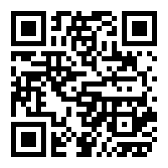

Click the below link to download E-content for Nov-2020 subjects or copy and paste this link in browser URL to Download E-content.

http://cscnandanamarts.tech/pages/econtent_ug_1.php

